
CLEAR REFLECTION

CHAIR CATEGORY
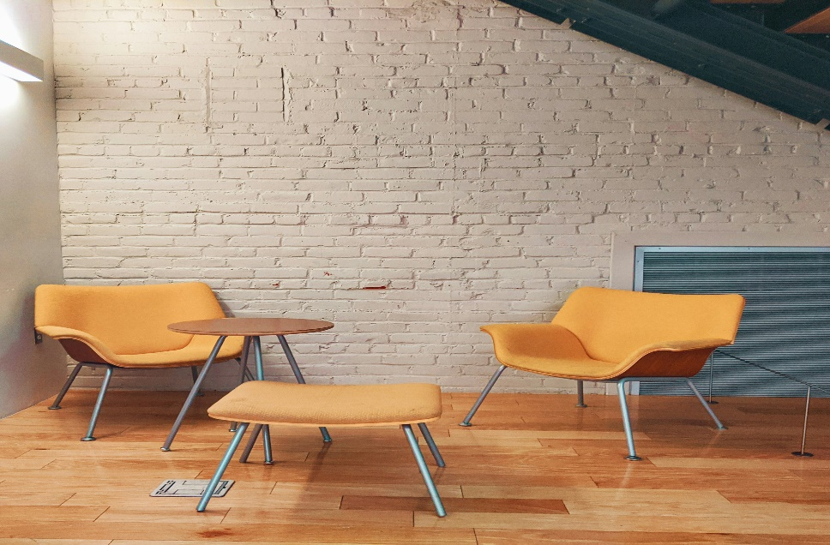
“ACCENT CHAIRS”
The accent chair is designed to make a bold style statement while providing exceptional comfort. Unlike regular seating, this chair is created to stand out and enhance the character of any room. With its unique shape, refined detailing, and eye-catching design, the accent chair becomes a focal point in living rooms, bedrooms, reading corners, or office spaces. It adds personality and charm while complementing the overall décor of the space. Built using high-quality materials, the accent chair offers both durability and elegance. The seat is generously cushioned to provide a relaxing seating experience, while the backrest offers proper support. The frame is crafted with precision to ensure stability and strength, making it suitable for everyday use. Its design allows it to pair beautifully with sofas, side tables, and decorative elements such as rugs and lamps. This accent chair is perfect for those who wish to add a touch of luxury and creativity to their interiors. It works well in modern, minimal, and luxury-themed spaces, adding warmth and sophistication. Whether used as a statement piece or as additional seating, the accent chair reflects refined taste and stylish living.

